**VNM Motion System and Sim-Motion Software Guide**

# 1. Download VNM UI

Download [VNM UI](https://vnmsimulation.com/download) and open it (add exception for VNM UI if computer detects virus). Click tab motion:

In Number of actuators: Choose exactly how many actuator in your motion system.

In Pulse Frequency: Choose whatever frequency as your liking. **We recommend you should try from 100-250 at the beginning.** After being familiar with motion system, you can choose higher frequency. The higher pulse frequency the higher speed of actuator.

Smoothing to make the motion system work smoother. The higher value, the higher smoothness.

Number pulse per loop is the number of pulses you want to send to actuator each 1ms. The higher value the faster of actuator’s speed.

Actuator stroke length: choose each actuator to config the length of stroke based on your system.

Other parameters should let it be as default of VNM Motion System.

# 2. Sim-Motion Configuration

Download [Sim-motion Software](https://eu.sim-motion.com/produkt/sim-motion-software-private-licence/?lang=en)

## 2.1. Setup Ouput

Click output (if you don’t see, double click to the top bar)

Choose number of actuators, choose “USB Controller” in Controller 1

Assign port to actuator front left – port 4; front right – port 1; rear left – port 3; rear right – port 2.

Click save

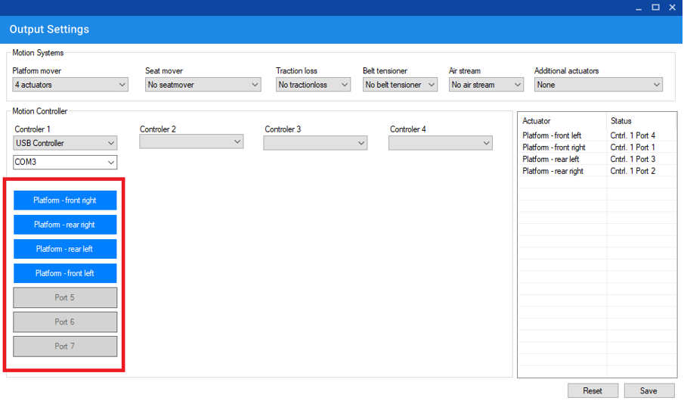

## 2.2. Motion Settings

Go to motion settings, click on each force item and adjust parameters as your liking (pls read README.txt of sim-motion software to understand the parametters)

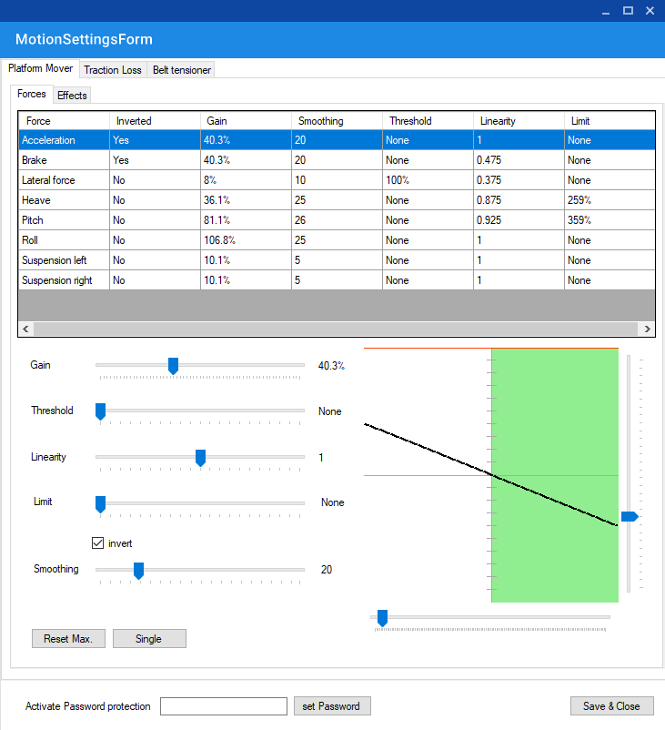

3. Test

Click on test button to test your motion system.

